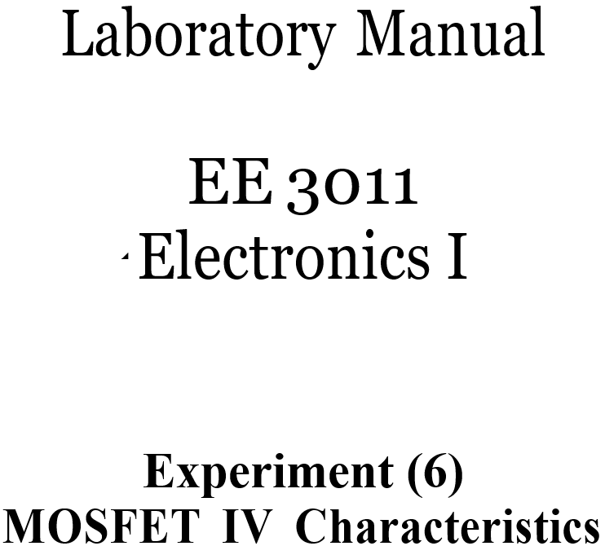

Ebubekir Mutugan
150720002

Pre-lab Work
Analyze the DC circuit below. Assume the transistor is in saturation and find expressions for the drain current and the drain-source voltage. Ignore channel length modulation.
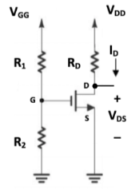

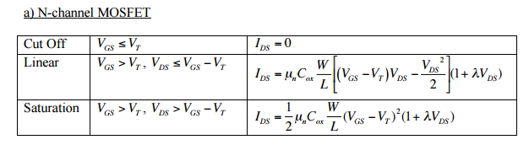

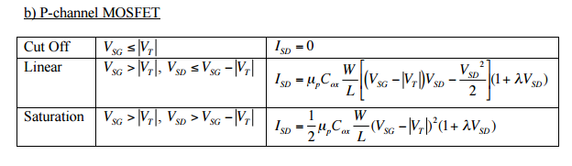

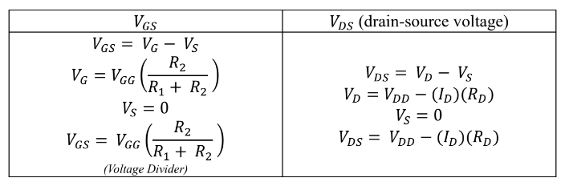

Part (1): MOSFET IV Characteristics.
- Calculate 𝑉_{𝐺𝑆} (using voltage divider rule) and the current 𝐼_{𝐷} (𝑉_{𝑅}𝐷/𝑅_{𝐷}) in table 2, for both values of 𝑉_{𝐺𝐺}.
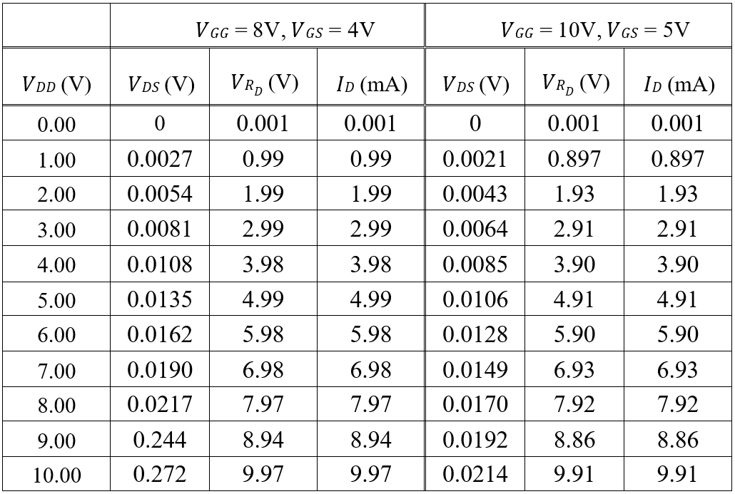

- Use graph 1 to sketch the IV curves (𝐼_{𝐷} versus 𝑉_{𝐷𝑆}) for the two 𝑉_{𝐺𝑆} values using the results in table 2.
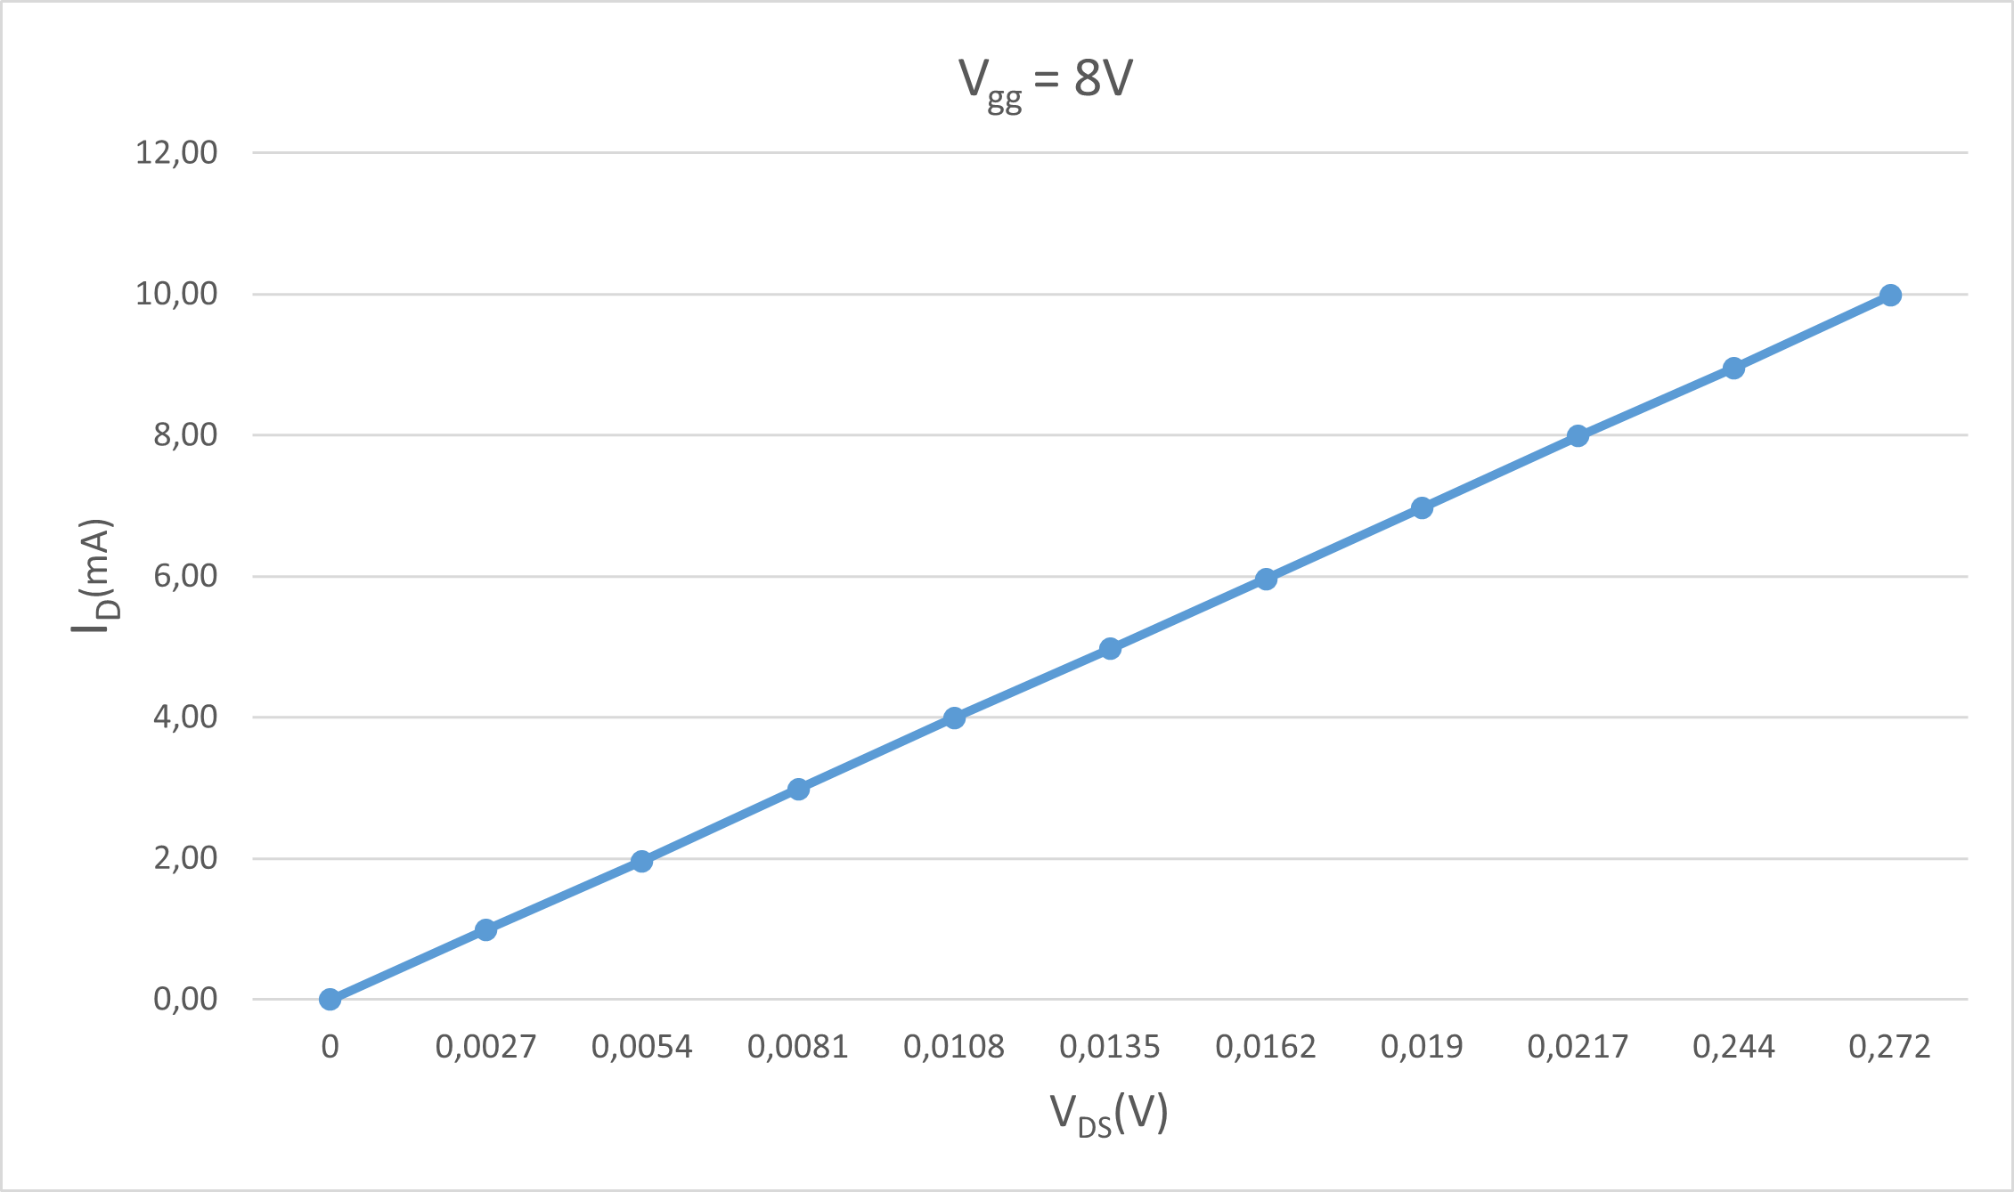

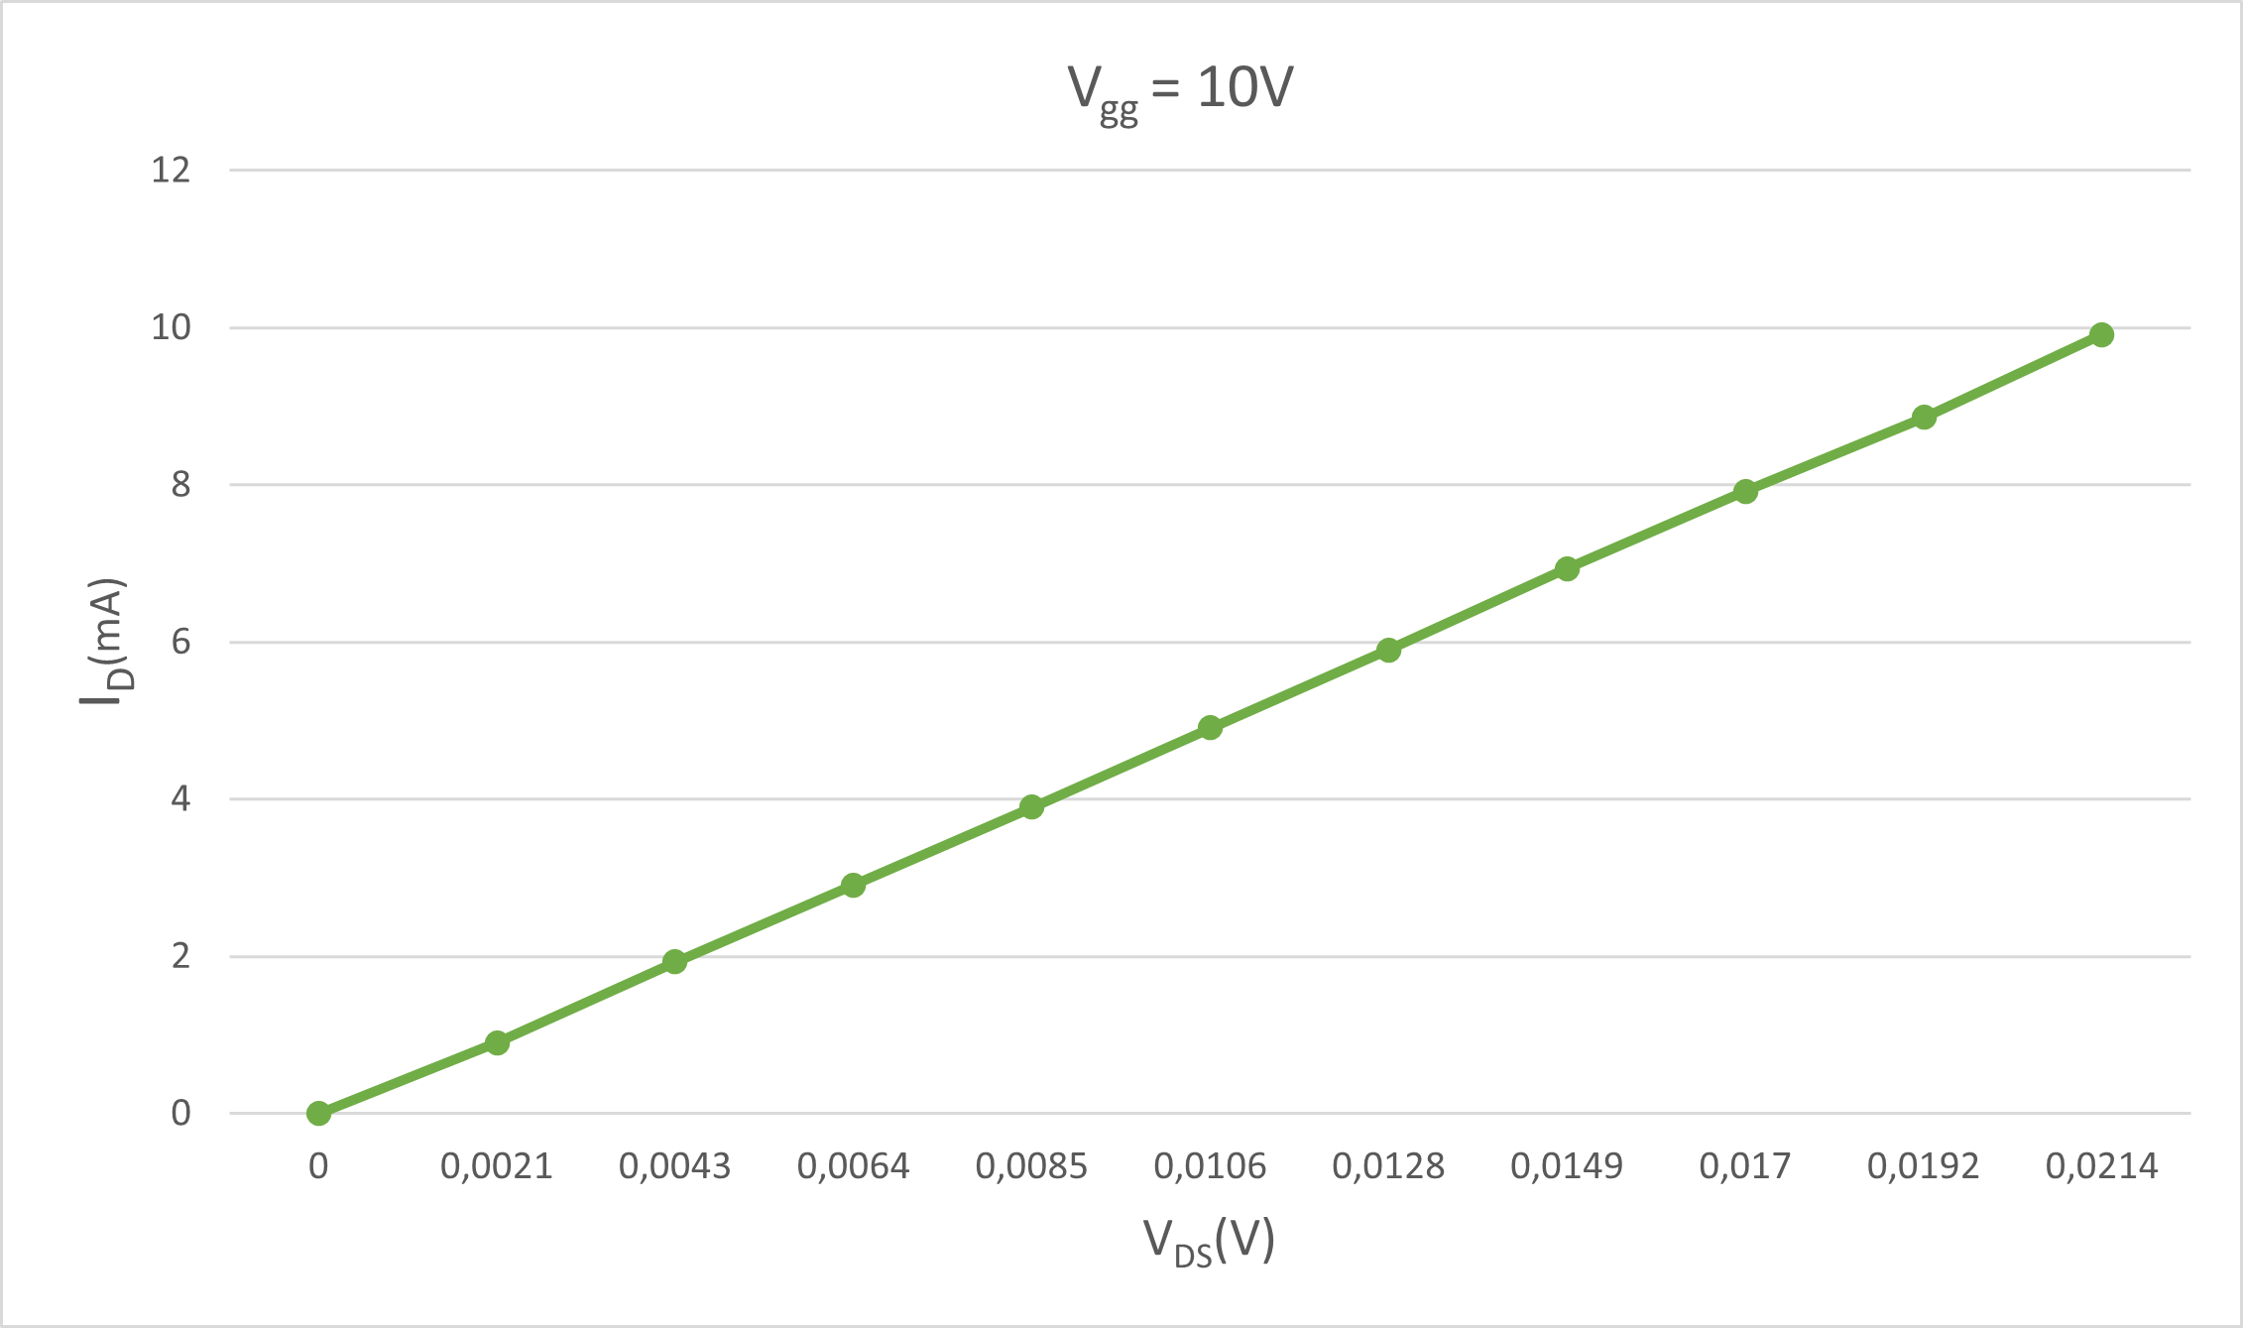

- Comment on the IV curves that you obtained. Can you identify the transistor modes of operation?
Based on the output graph, we can say that the transistor is linear in saturation mode
- Is the drain current constant in the saturation region of the IV curve? Explain why or why not.
Not constant but increasing linearly. Since our slope is 1/r₀

Part (2): Graphical Analysis of a DC MOSFET Circuit.
- The load equation fort he circuit is I_{D} = (V_{DD}-V_{DS})/R_{D}. It is line connecting the two point (0, V_{DD}/ R_{D}) and (V_{DD},0) on the IV curve.
Points are (0,10) and (10,0).

- Draw the load line on top of the IV curves in graph 1. Mark the intersection point of the curves.
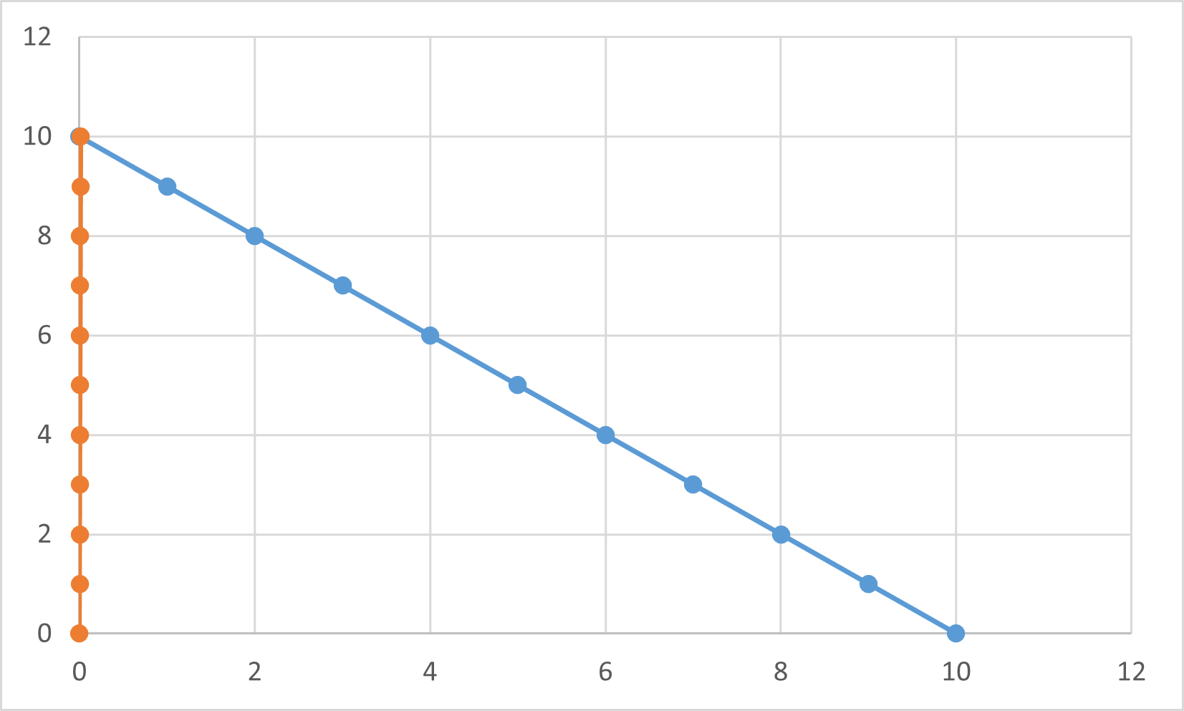

- The intersection of the load line and the IV curve gives the operating point of the circuit. Read the drain current (𝐼_{𝐷}) value and the drain-source voltage (𝑉_{𝐷𝑆}) value from the intersection point in graph 1. Record the results in table 3.

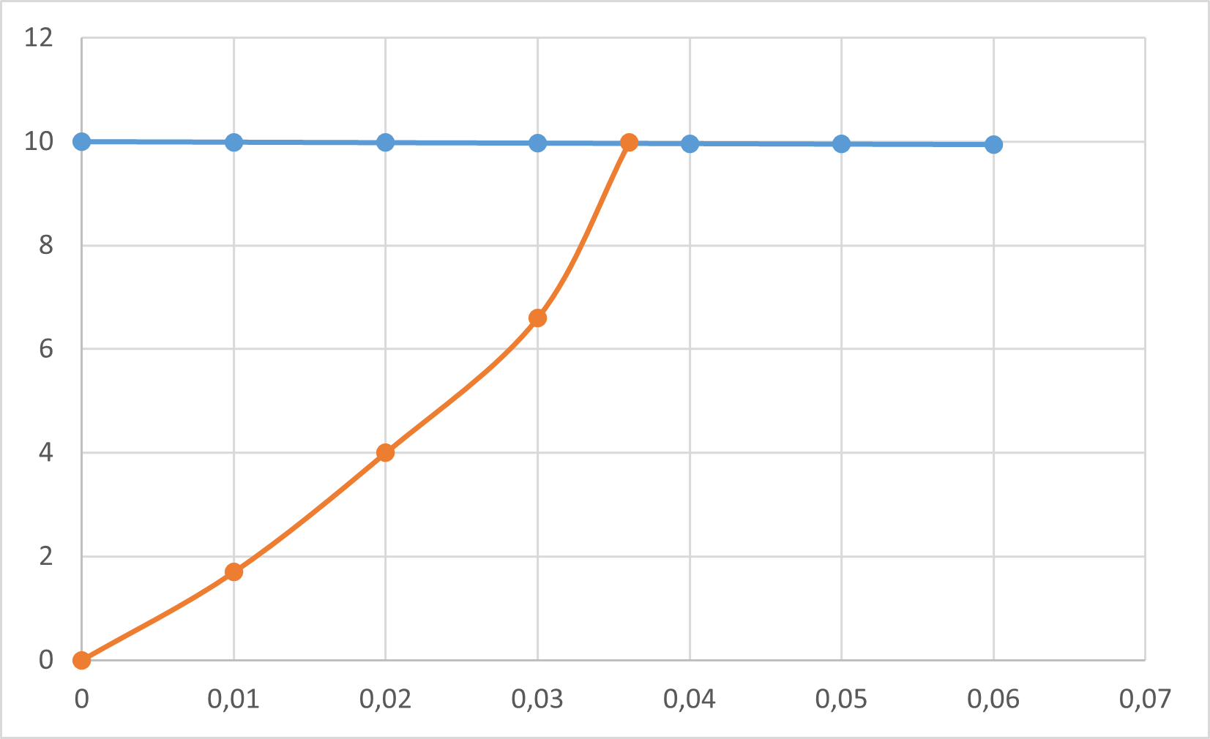
- The experimental value of 𝐼_{𝐷} = (𝑉_{𝐷𝐷} − 𝑉_{𝐷𝑆})/𝑅_{𝐷}.
𝑉_{𝐷𝐷}= 10 V and 𝑉_{𝐺𝐺} = 10 V
𝑉_{𝐷𝑆} (V) Experimental value | 𝑉_{𝐷𝑆} (V) Graphical value | %  Difference | 𝐼_{𝐷} (mA) Experimental value | 𝐼_{𝐷} (mA) Graphical value | %  Difference
0,024 | 0,026 | 7,6923 | 10,01 | 9,97 | 0,4011

5. Comment on your results explaining the sources of differences.
If we increase the voltage value more slowly, the error decreases

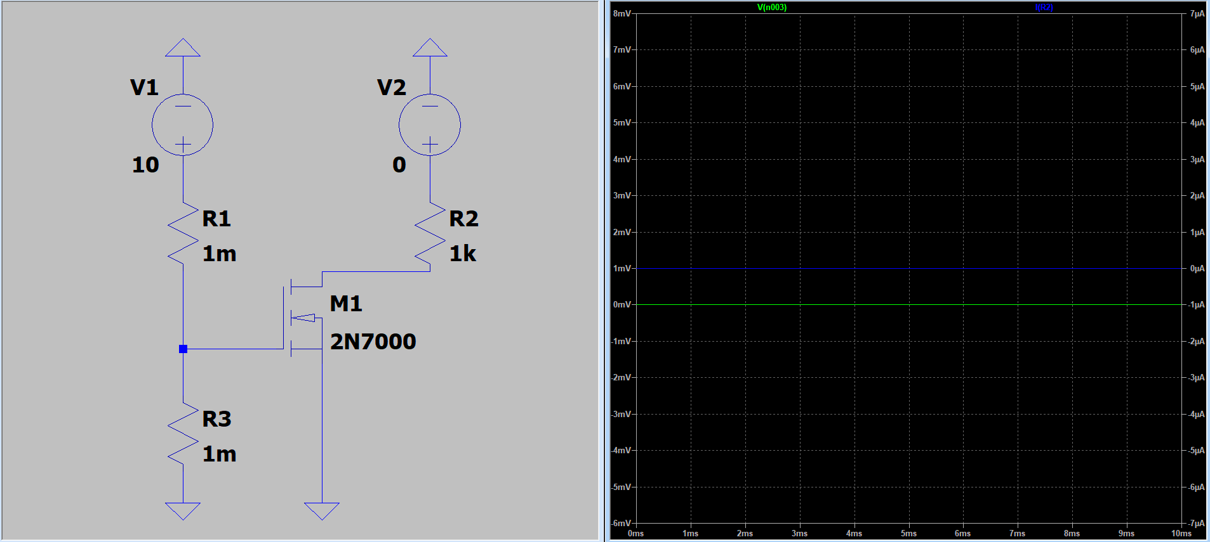
Ltspice

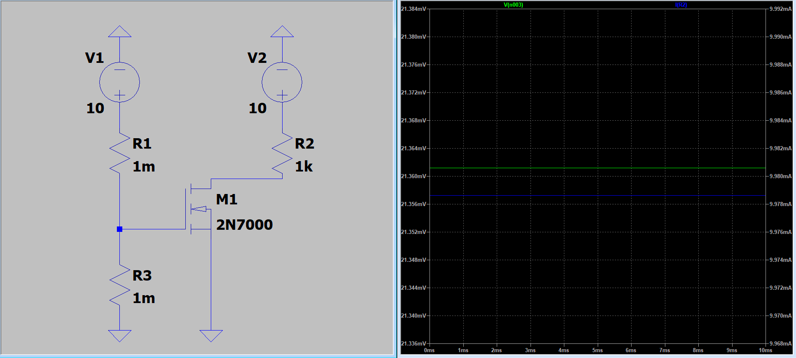
𝑉_{𝐷𝐷}= 0 V and 𝑉_{𝐺𝐺} = 10 V

𝑉_{𝐷𝐷}= 10 V and 𝑉_{𝐺𝐺} = 10 V
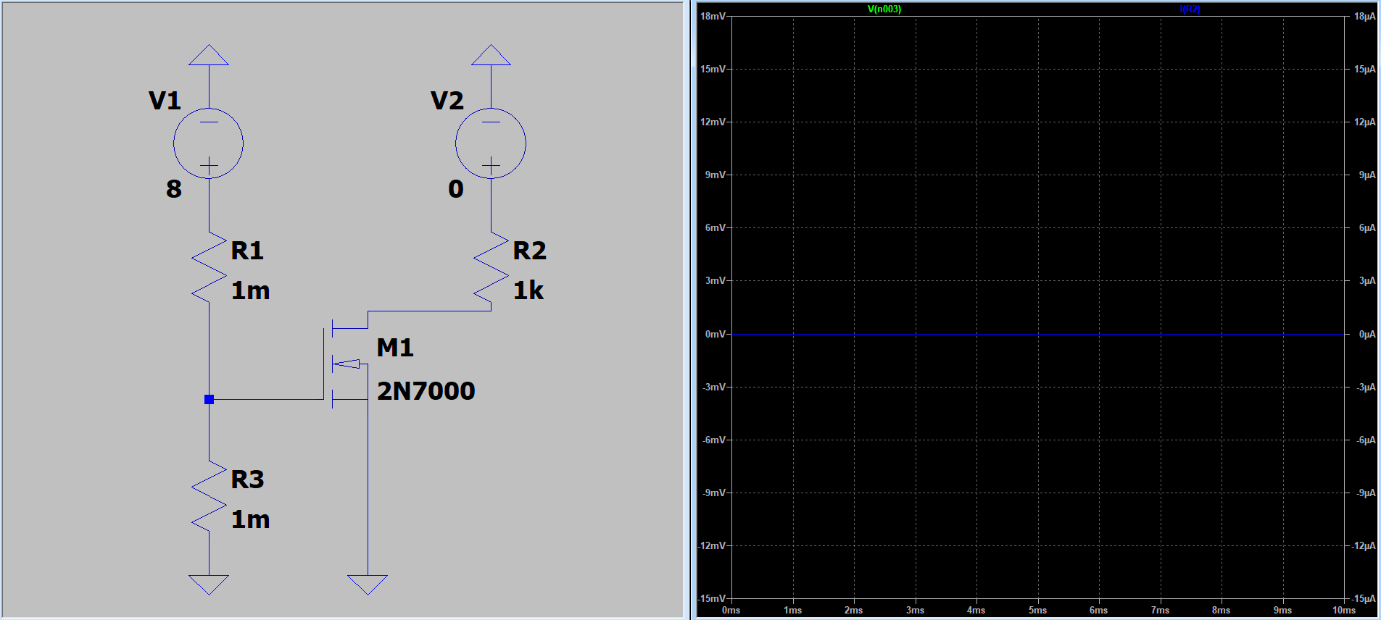
𝑉_{𝐷𝐷}= 0 V and 𝑉_{𝐺𝐺} = 8 V
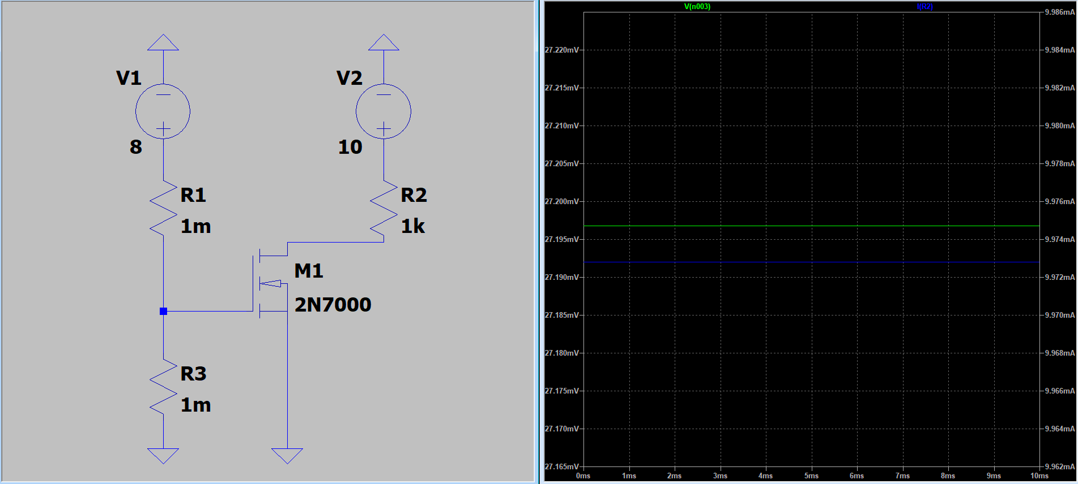
𝑉_{𝐷𝐷}= 10 V and 𝑉_{𝐺𝐺} = 8 V


